**C768, Task 3**

**Tyler E Darby**

**Western Governors University**

**Email** **3**

A1. Email Tone 3

A2. Email Jargon 3

A3. Email Message Timing 4

**PowerPoint (or other presentation software)** **5**

B1. Slides 5

B2. Visual Elements 15

B3. Audience and Tone 15

B4. Audience and Jargon 16

**Panopto Presentation** **1**6

**Sources** **17**

# **Email**

To: Financial and IT Department Colleagues

From: Tyler Darby<tdarb15@my.wgu.edu>

Subject: Introducing Cryptocurrency

Hello esteemed colleagues,

I am reaching out today to invite you to a web presentation on the possibility of introducing the use of cryptocurrency at Get Good Games website. We should always be looking for new ways to improve our company and I have hopes that cryptocurrency may do just that. Mainly there are 3 areas cryptocurrency is expected to benefit Get Good Games.

* Saving the company money through avoidance of financial institution fines
* Increasing sales and customer base as well as the average value of transactions
* More secure transactional security due to the technology cryptocurrencies are built on

You have been invited to this presentation because your input and expertise are valued and sought after in order to present the best possible functionality for our customers. The presentation will be held on Friday the 21st at 11 am. Please join via the link following this email.   
  
Tyler Darby

## A1. Email Tone

I chose to take a less formal tone here because I felt it was important to make my coworkers feel that their attendance and input were extremely valued for this proposal. This will take a team effort to implement so it’s important all departments involved feel included and comfortable so I decided a casual tone was best in this case. I hope that the readers feel excited and optimistic about the new technology proposal and look forward to hearing my presentation.

## A2. Email Jargon

In my email I assumed that most of the team must be familiar with cryptocurrency as they work professionally in the financial and IT departments. Anyone who may be unfamiliar with it or have more questions would contact me by email or come to the presentation and have their question answered. I was afraid that if I did not keep the email simple it could confuse employees or give them a negative bias before even attending the meet. This email would also serve a purpose to make employees aware of the new technology they need to be “In the Know” on for work.

## A3. Email Message Timing

I believe my message could be misinterpreted if an employee assumed we would be replacing the use of the credit/debit card transactions since I did not specify as such. I believe this will benefit the project by encouraging the audience to ask questions, get involved and come to the presentation. I believe the best time for this communication to be released would be on a day that had no other planned major changes for the company as to ensure the audience does not feel their focus will need to be devided. It would be important to be sensitive to the office environment and current events, it would not be appropriate to send this email at a time where the stress levels of the team are extremely high. As this is an email intended only for the financial and IT department it would not be appropriate for it to be shared outside of the intended audience.

# PowerPoint (or other presentation software)

My slide presentation introduces the benefits of accepting cryptocurrency as a form of payment on Get Good Games video game selling website. I wanted to focus on all the benefits of introducing functionality like this to the overall company. I looked for very basic stock photos to capture the subject of the slide but wanted to make sure the focus was on the information I was presenting and not the illustrations on the screen.

**Please also upload a copy of your White Paper.**

## B1. Slides

In my presentation there are 10 slides in total.

Slide 1: 

Slide 2: 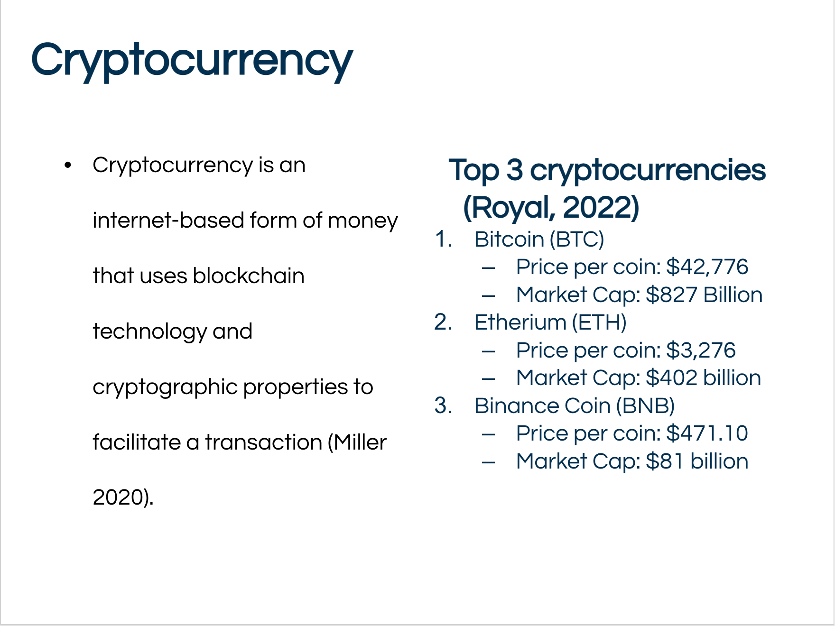

Slide 3: 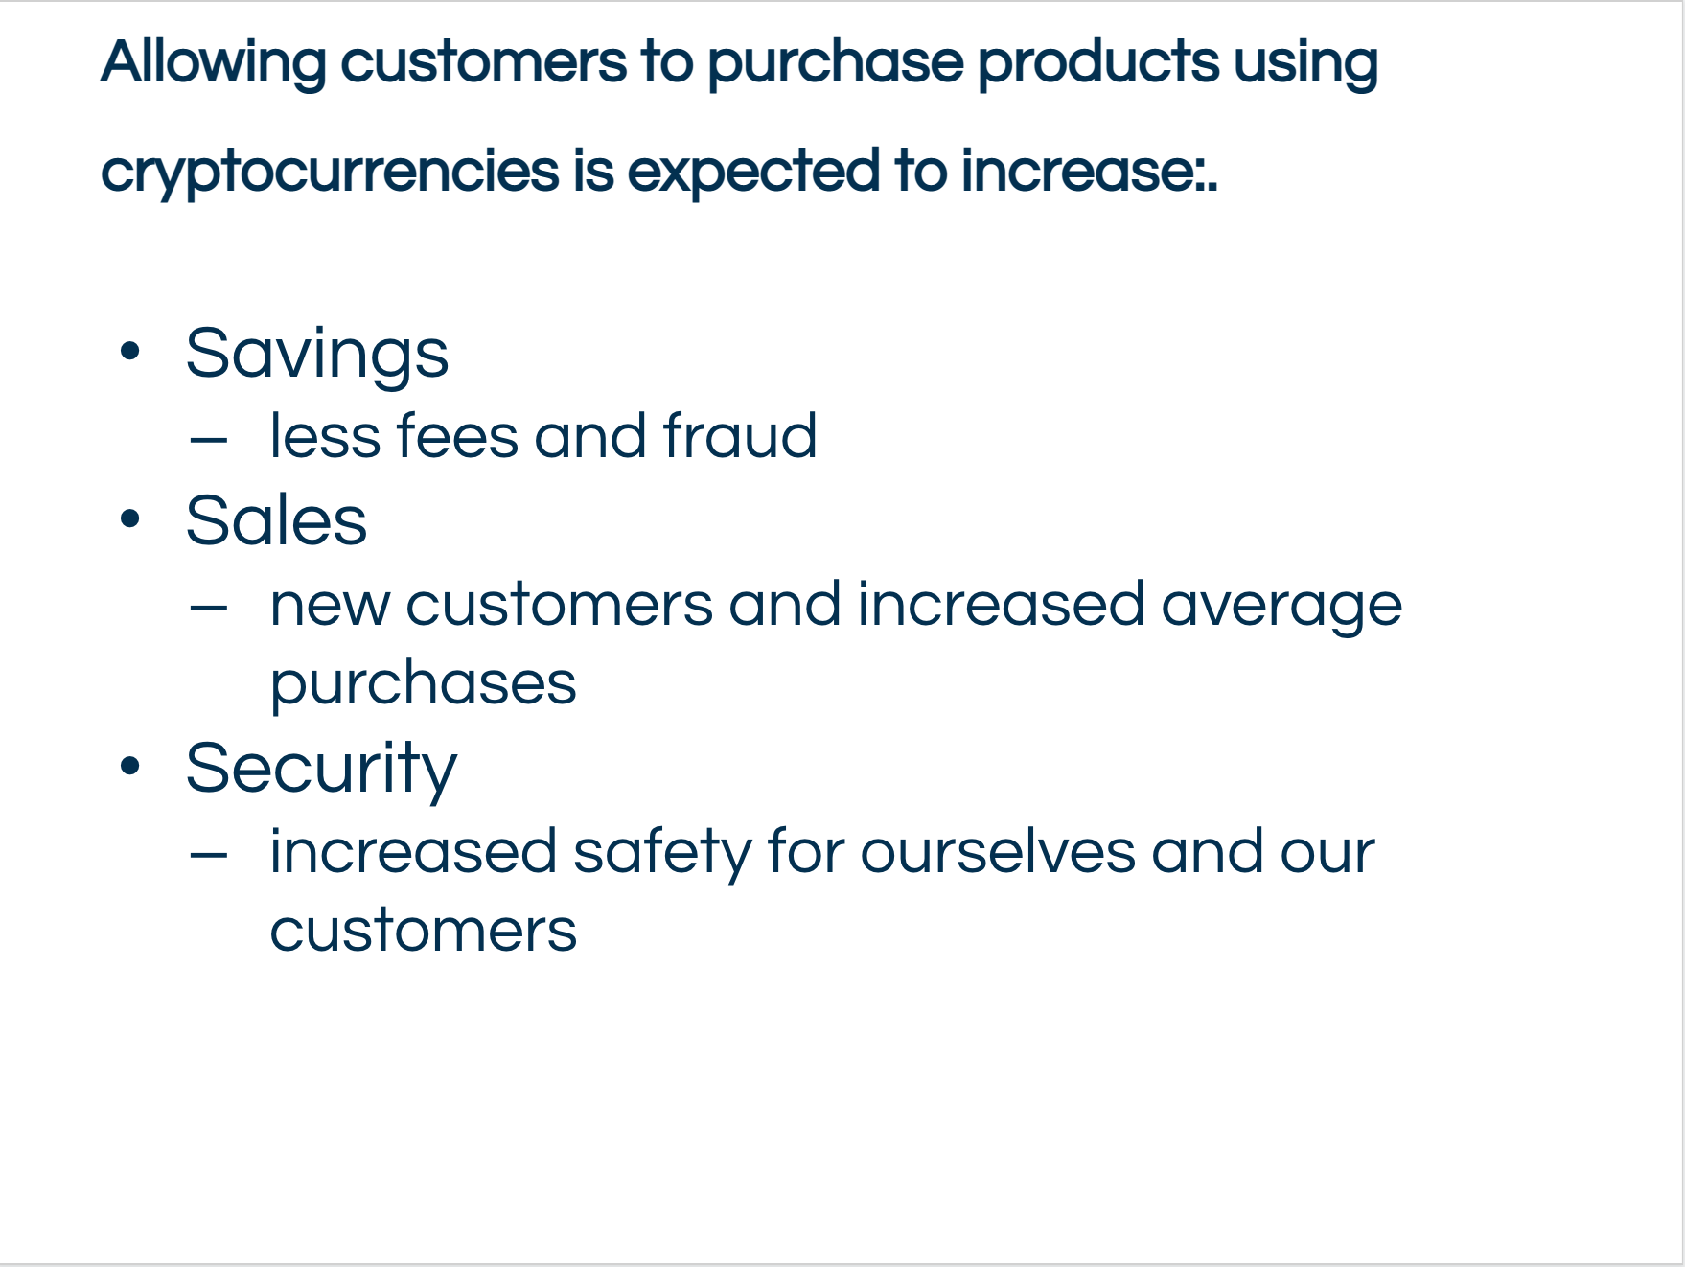

Slide 4: 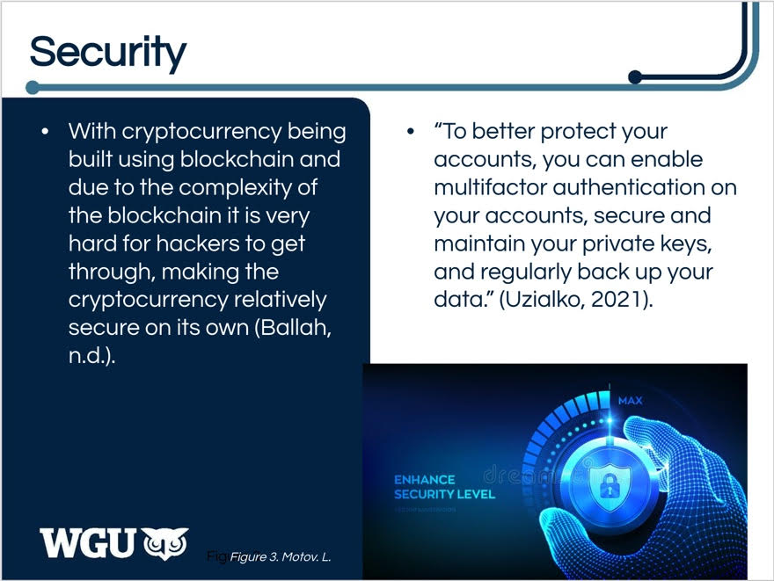

Slide 5: 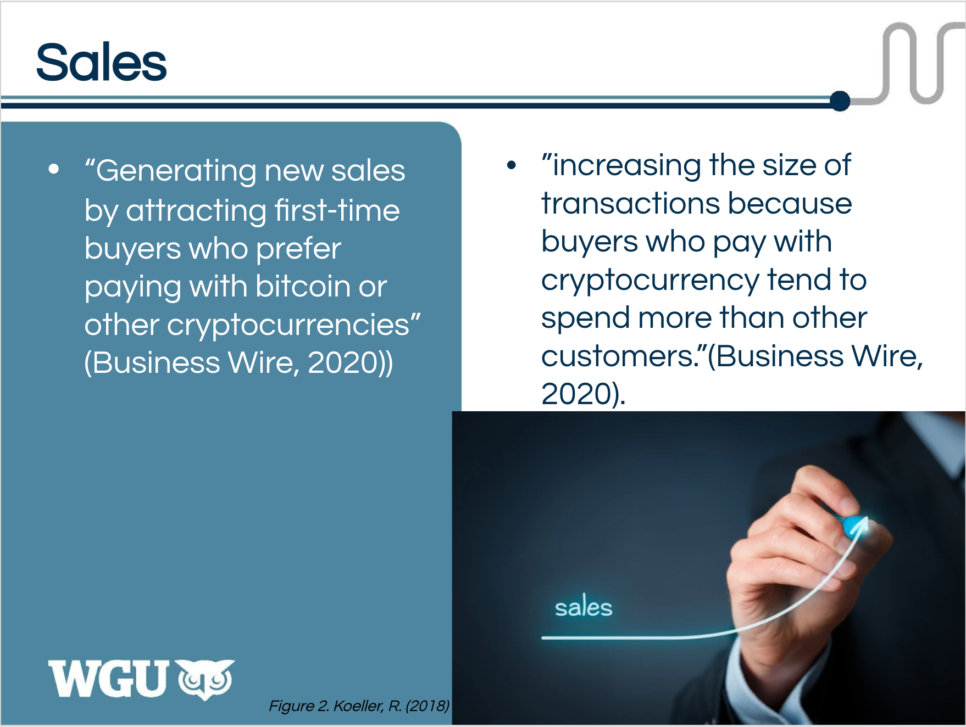

Slide 6: 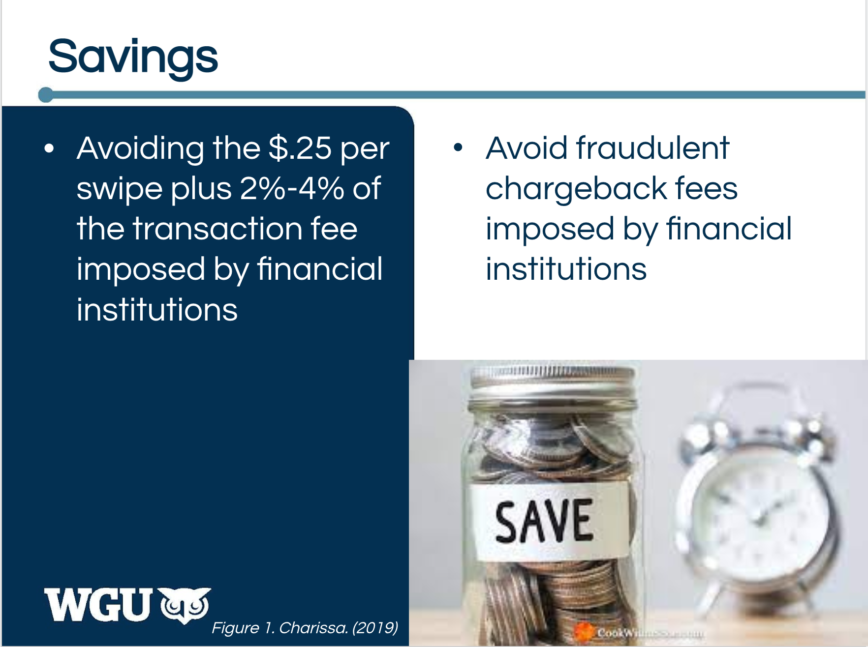

Slide 7: 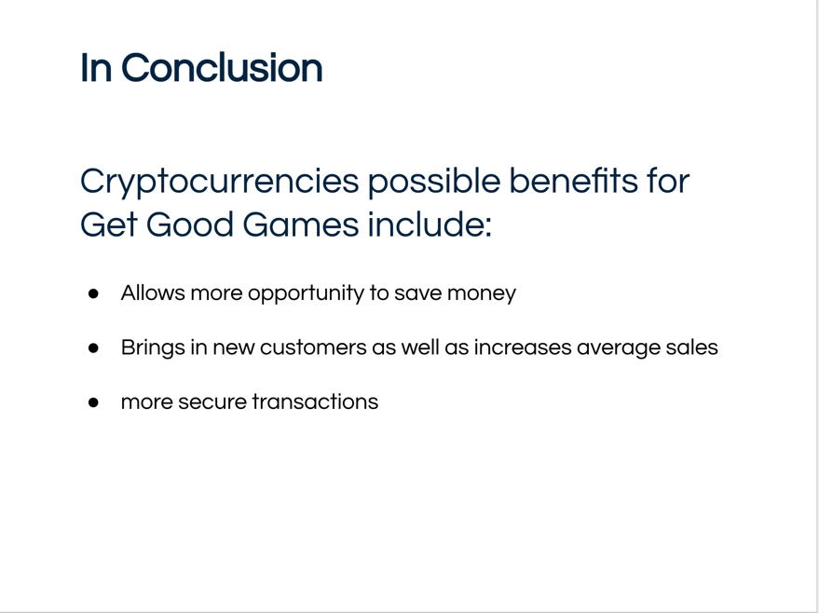

Slide 8: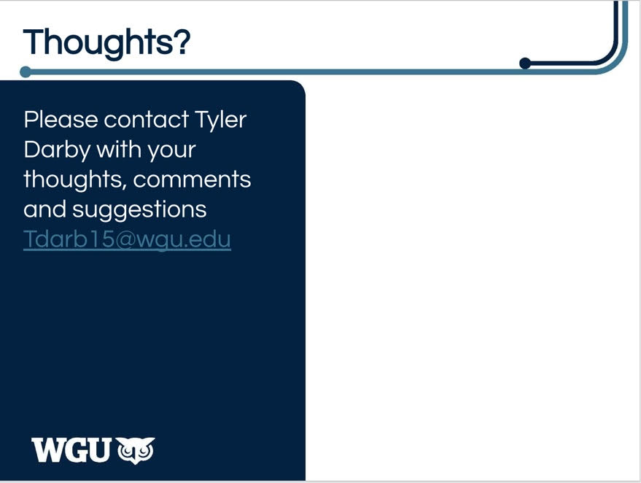

Slide 9: 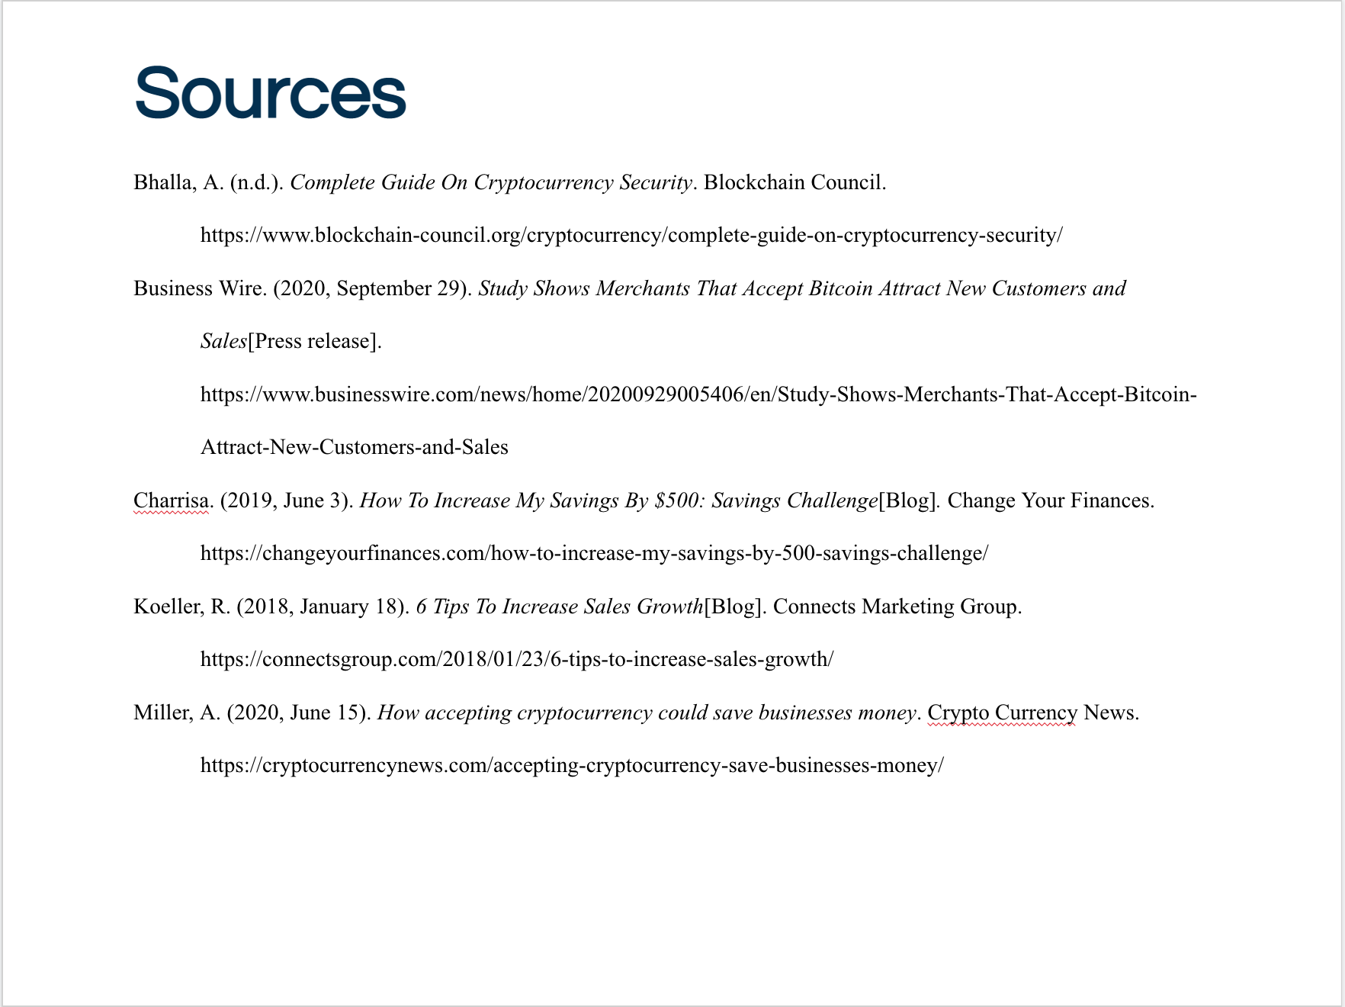

Slide 10: 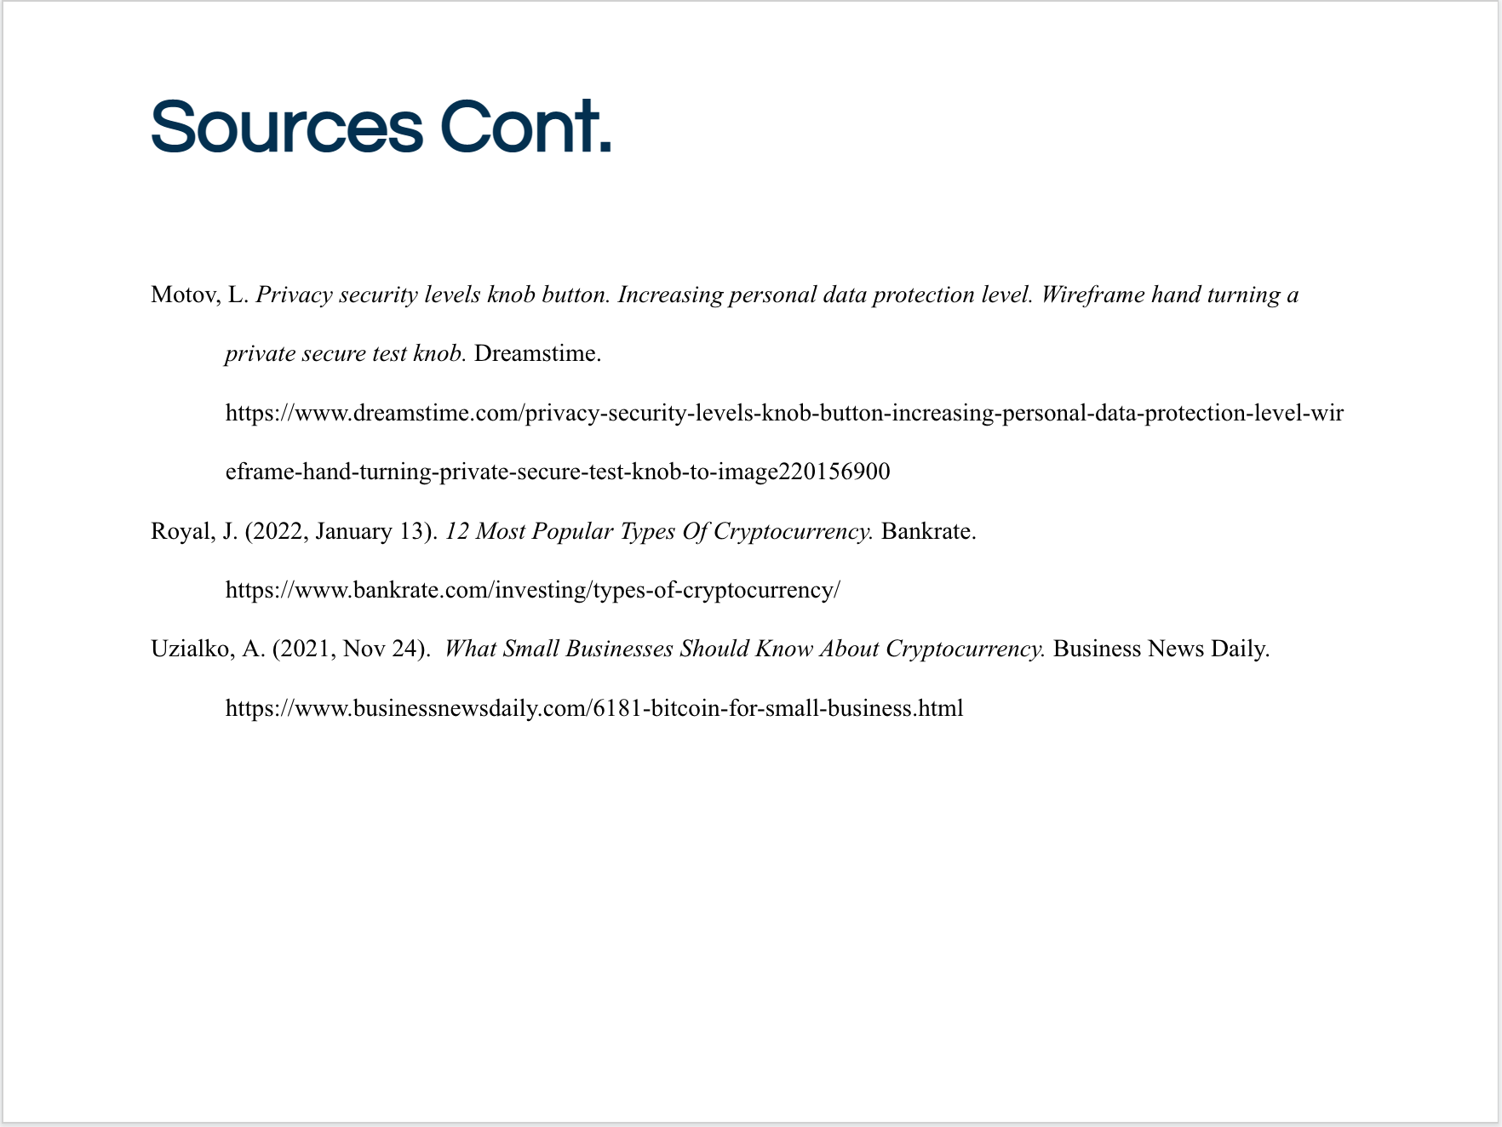

## B2. Visual Elements

There are a total of 3 visual elements in my presentation.

## B3. Audience and Tone

While my audience is the same as my email, it is still a proposal presentation to a team of coworkers so I kept a formal tone for the presentation. It is important this is taken seriously and all involved are up to date on the possible project. Keeping a formal presentation encourages employees to pay attention and understand the importance of this proposal.

## B4. Audience and Jargon

In my presentation I assumed that most of the team must be familiar with cryptocurrency as they work professionally in the financial and IT departments. Anyone who may be unfamiliar with it or have more questions would contact me by email to get anymore questions answered. I was afraid that if I did not keep the presentation simple it could confuse employees or give them a negative bias over the meeting and proposal. This presentation would also serve a purpose to make employees aware of the new technology they need to be “In the Know” on for work.

# Panopto Presentation

<https://wgu.hosted.panopto.com/Panopto/Pages/Viewer.aspx?id=805d1fc1-56b4-492e-941e-ae22010d9946>

# 

# Sources

Bhalla, A. (n.d.). *Complete Guide On Cryptocurrency Security*. Blockchain Council. https://www.blockchain-council.org/cryptocurrency/complete-guide-on-cryptocurrency-security/

Business Wire. (2020, September 29). *Study Shows Merchants That Accept Bitcoin Attract New Customers and Sales*[Press release]. https://www.businesswire.com/news/home/20200929005406/en/Study-Shows-Merchants-That-Accept-Bitcoin-Attract-New-Customers-and-Sales

Charrisa. (2019, June 3). *How To Increase My Savings By $500: Savings Challenge*[Blog]*.* Change Your Finances.

https://changeyourfinances.com/how-to-increase-my-savings-by-500-savings-challenge/

Koeller, R. (2018, January 18). *6 Tips To Increase Sales Growth*[Blog]. Connects Marketing Group.

https://connectsgroup.com/2018/01/23/6-tips-to-increase-sales-growth/

Miller, A. (2020, June 15). *How accepting cryptocurrency could save businesses money*. Crypto Currency News.

https://cryptocurrencynews.com/accepting-cryptocurrency-save-businesses-money/

Motov, L. *Privacy security levels knob button. Increasing personal data protection level. Wireframe hand turning a private secure test knob.* Dreamstime. https://www.dreamstime.com/privacy-security-levels-knob-button-increasing-personal-data-protection-level-wireframe-hand-turning-private-secure-test-knob-to-image220156900

Royal, J. (2022, January 13). *12 Most Popular Types Of Cryptocurrency.* Bankrate.

https://www.bankrate.com/investing/types-of-cryptocurrency/

Uzialko, A. (2021, Nov 24). *What Small Businesses Should Know About Cryptocurrency.* Business News Daily. https://www.businessnewsdaily.com/6181-bitcoin-for-small-business.html